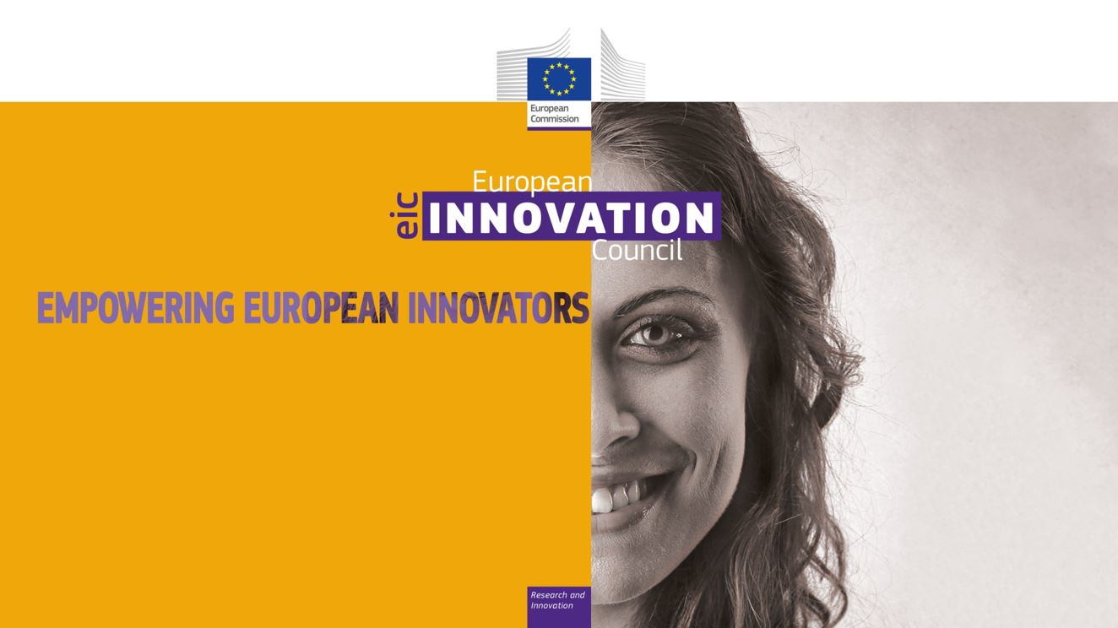

Greek Edition of the EIC Roadshow
Thursday, 11 July 2019
Venue: NCSR "Demokritos", Neapoleos, Ag. Paraskevi 153 10, Athens
11:00 – 11:30 | Welcome Coffee
11:25 – 11:30 | Welcome address (tbc)
POLICY: WHY AN EIC?
11:30 – 11:50 | Introduction to the European Innovation Council (EIC)  By Jean-David Malo, Director of the EIC Task Force, DG Research and Innovation, European Commission
11:50 – 12:20 | Panel discussion with  - Jean-David Malo, Director, European Commission  - Representative from the General Secretariat for Research and Technology (GSRT)(tbc)  - TBD, Academic expert  - Beneficiary of an SME Instrument Phase II Grant  Moderator: Eric-Olivier Pallu, European Commission
12:20 – 12:30 | Q&A
IMPLEMENTATION: HOW TO RECEIVE FUNDING?
12:30 – 13:05 | The EIC in more details: Specific elements and novelties of the revised Work Programme 2019-2020, calls opening, cut-off dates  By Timo Hallantie, Head of Unit REA A-5, EIC Task Force, DG R&I, European Commission
13:05 – 13:15 | How to receive support from the Greek NCPs – ΕΕΝ [GR-NCPs]
13:15 – 13:30 | Q&A discussion
13:30 – 14:30 | Lunch Break

