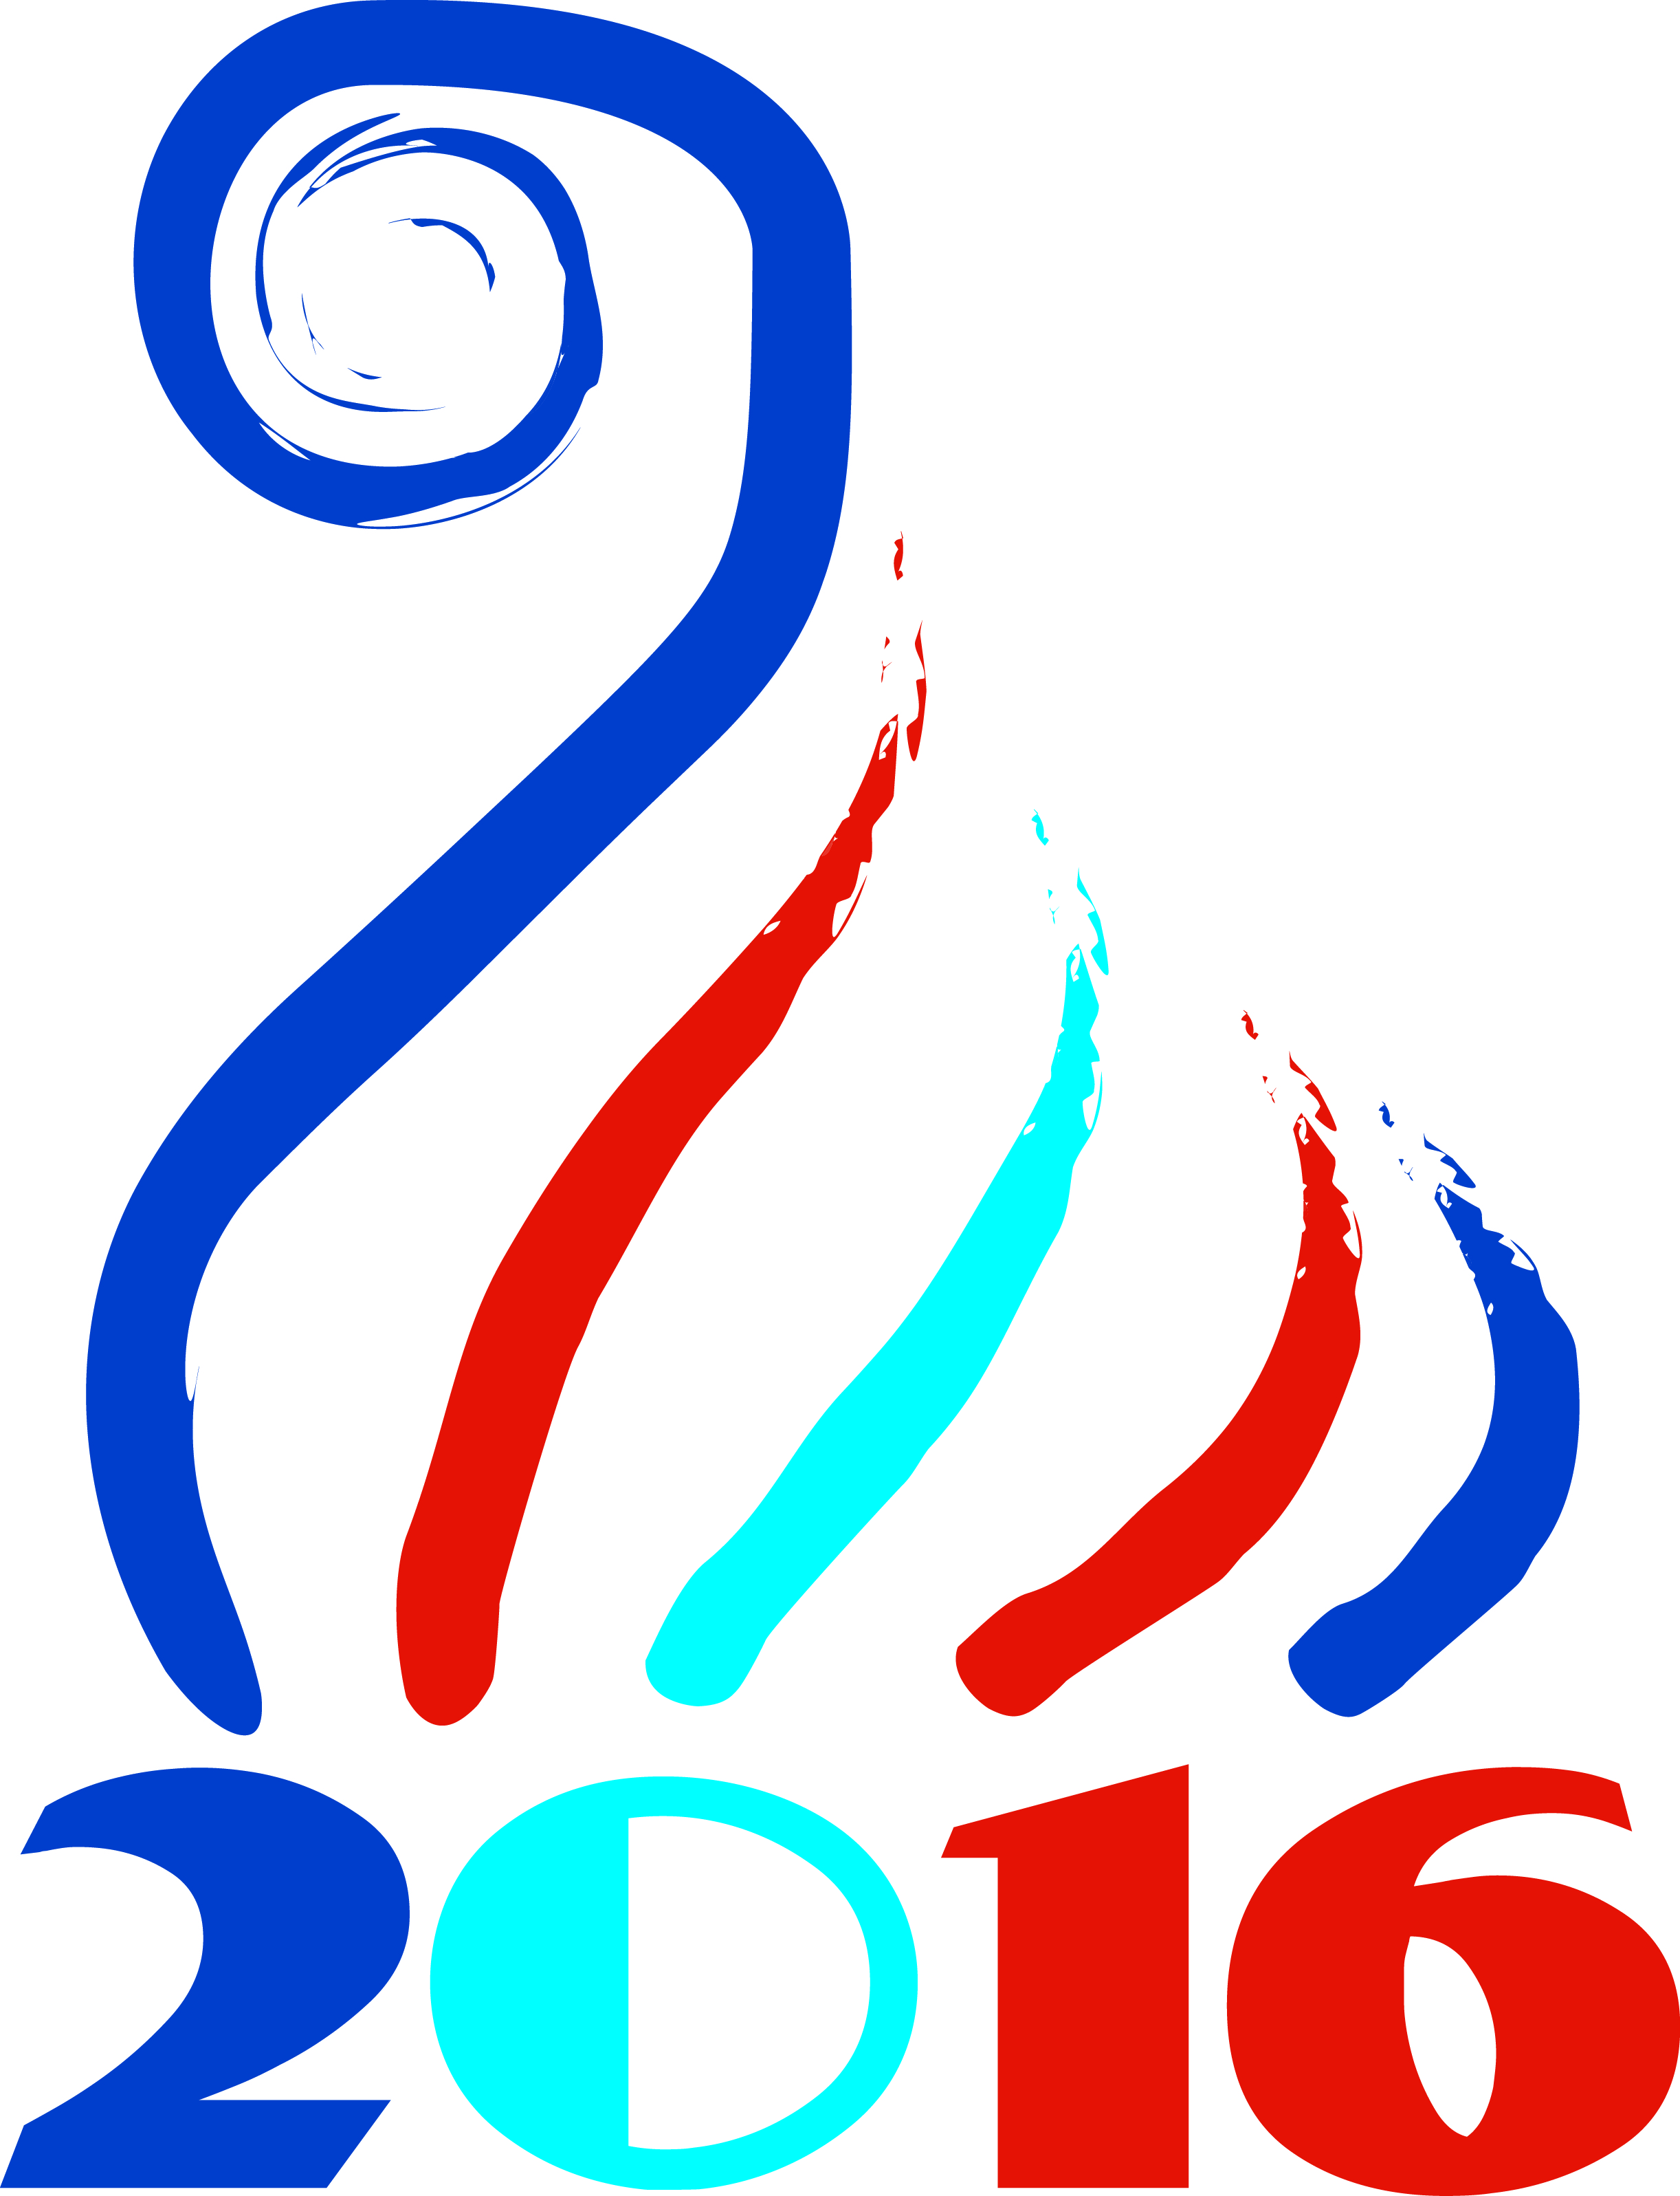
Greek-Russian Workshop on Quantum Technologies
co-organized by

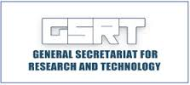
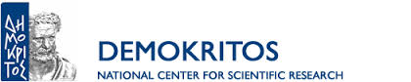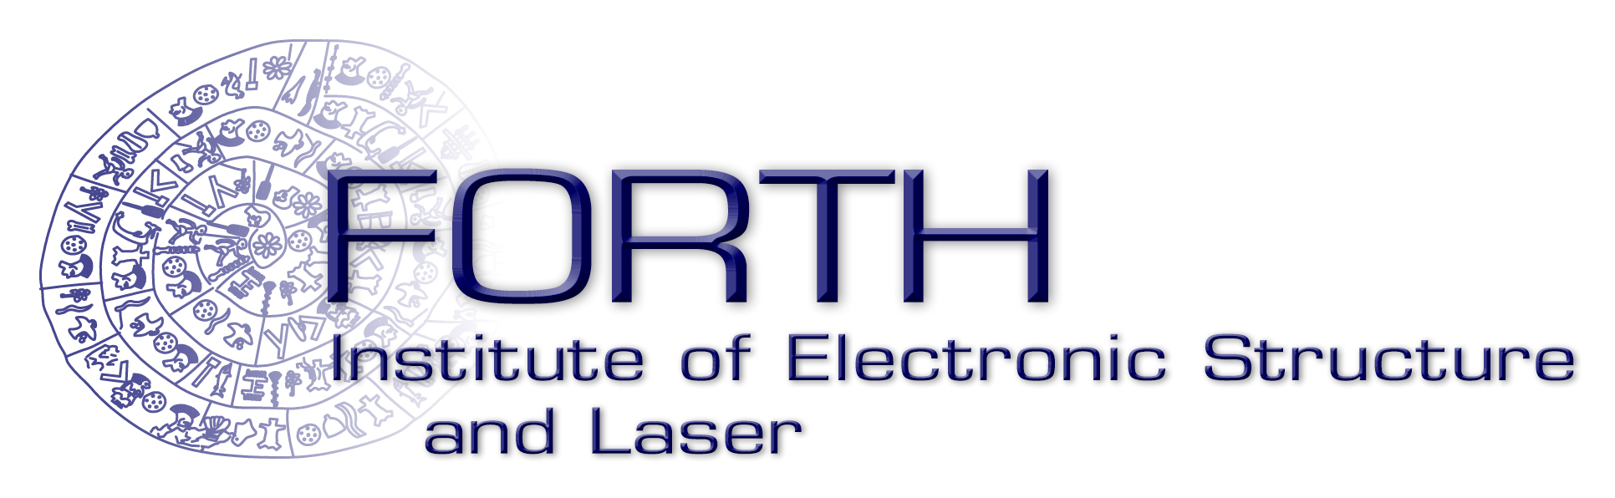

Athens, Greece, 1-2 April 2016
NCSR “DEMOKRITOS”

Friday, April 1

Registration

8.30-9.00 (Lecture Hall 3/Building 8)

Welcome address

9:00-9:10 Dr. Nikolaos KANELLOPOULOS, Chairman of the Board and Director of NCSR “DEMOKRITOS”

Session I: Quantum Nanoelectronics
Chair: D. CHARALAMBIDIS

9:10-9:30 Konstantin ARUTYUNOV (MIEM, National Research University Higher School of Economics, Moscow Institute of Electronics and Mathematics,) "Nano-scale superconductivity"
9:30-9:50 Panagiotis ARGITIS (National Center for Scientific Research “DEMOKRITOS”) "Molecular interfacial layers for organic optoelectronics"
9:50-10:10 Valery RYAZANOV (Chernogolovka) "Coherent and nonequilibrium phenomena in hybrid Josephson structures"
10:10-10:30 George DELIGIORGIS (FORTH, Foundation for Research and Technology - Hellas) "Graphene and CNT transistors"
10:30-10:50 Georgy GOLTSMAN (MGPU, Moscow State Pedagogical University) “Single photon detectors”
10:50-11:10 Andrei ZAIKIN (LPI RAS, Lebedev Physical Institute of the Russian Academy of Sciences) “Quantum fluctuations in superconducting nanowires"

11:10-11:40 Coffee Break

Session II: Quantum Information – Communication
Chair: G. TSIRONIS

11:40-12:00 Alexey USTINOV (MISIS, National University of Science and Technology, Moscow) "Superconducting quantum circuits"
12:00-12:20 Oleg ASTAFIEV (MPTI, Moscow Institute of Physics and Technology) "Quantum optics on-chip"
12:20-12:40 Georgios NIKOLOPOULOS (FORTH, Foundation for Research and Technology - Hellas) “Quantum communication & cryptography”
12:40-13:00 Evgenii ILICHEV (NGTU, Novosibirsk State Technical University) "Quantum detectors and amplifiers"

13:00-14:10 Lunch Break (Library – Exhibition Center – Building 15)

Session III: Photonics
Chair: K. ARUTYUNOV

14:10-14:30 Alexander SERGEEV (IAP RAS, Institute of Applied Physics of the Russian Academy of Sciences) “Subexawatt Laser Project XCELS”
14:30-14:50 Ildar GABITOV (Skoltech,Skolkovo Institute of Science and Technology) "Polarization switching on rf-SQUID based metasurfaces"
14:50-15:10 Stavros PISSADAKIS (FORTH, Foundation for Research and Technology - Hellas) “Photonics in Greece, research directions and prospects”
15:10-15:30 Dimitris CHARALAMBIDIS (University of Crete and FORTH, Foundation for Research and Technology - Hellas) “Ultrafast dynamics, femto-, atto- and all that”
15:30-15:50 Pavlos SAVVIDIS (Univ. of Crete and FORTH, Foundation for Research and Technology - Hellas) “Manipulating polariton condensates on a chip”
15:50-16:10 Pavlos LAGOUDAKIS (Skoltech,Skolkovo Institute of Science and Technology) “Engineering polariton simulators”
16:10-16:30 Dimitris SYVRIDIS, (University of Athens) “Non-linear dynamics of coupled semiconductor lasers with applications in secure communications and sensing”

16:30-17:00 Coffee Break

17.00 – 18.00 Workshop addresses* (Lecture Hall 3/Building 8)
Chair: N. KANELLOPOULOS

17:00-17:10 Prof. Thomas MALOUTAS, General Secretary for Research and Technology
17:10-17:20 Penelope-Maria SPILIOTI, Head of the directorate for International Research and Technology Collaborations, General Secretariat for Research and Technology
17:20-17.30 Prof. Spiros ANASTASIADIS, Director of FORTH-IESL

17:30-17:40 Ludmila OGORODOVA, Deputy Minister of Education and Science of the Russian Federation
17:40-17:50 Irina KUKLINA, Executive Director International Centre for Innovation in Science Technology &Education
17:50-18:00 Dmitry KOROTKOV, Head of Division Department of Science and Technology
* Ιn the Presence of Vladimir MAKSIMOV, Scientific Attaché – Embassy of the Russian Federation

Saturday, April 2

Session IV: Quantum Materials
Chair: A. USTINOV

9:00-9:20 George TSIRONIS (University of Crete and FORTH, Foundation for Research and Technology - Hellas) “Quantum Meta-materials”
9:20-9:40 Sergei MUKHIN (National Univ. of Science and Technology, Moscow) “Instantonic states of resonator with Majorana fermions”
9:40-10:00 George NEOFOTISTOS (University of Crete) “Chimera states in magnetically driven SQUID metamaterials”
10:00-10:20 George KONSTANDINIDIS (FORTH, Foundation for Research and Technology - Hellas) “Hybrid superconductor/2DEG nanostructures”

10:20-10:40 Coffee Break

10:40-12:00 Demokritos Labs visit

12:00-12:30 Common session of the four working groups (pillars). Defining working modus and task allocation (Lecture Hall 3/Building 8)

12:30-13:30 Lunch Break (Library – Exhibition Center – Building 15)

13:30-14:30 Separate editorial meetings of the four working groups (Library – Exhibition Center – Building 15)
14:30-15:20 Common session of the four working groups
Reporting of the working group coordinators (Lecture Hall 3/Building 8)
15:20-17:15 Finalizing the collaboration program proposal document. Further actions
17:15-17:30 Closing remarks, Dr. Maria DOUKA, Scientific Advisor, Office of the Alternate Minister for Research and Innovation

End of the Workshop

